Technical Specification

***Purpose:***

Choose how to fill your hotel Minibar.

***Goals:***

Develop the fundament in a way that allows further integrations with other software

***Site Map:***

*Choose Language* – In this page user must be able to choose from several languages.

*Choose Country* – In this page user must be able to choose the country his/her booked hotel is in.

*Choose Hotel* – Choose the booked hotel.

*Minibar Fill Typ*e – User must be able to choose between default minibar and a custom one. *(If we do not have a contract with the chosen hotel allow only default Minibar choice)*

*Product Categories* – If Custom minibar is selected open this page. This page displays two categories to choose from Food and Drink.

*Product Subcategories* – This page displays subcategories to choose from.

*Product Brands* – This page displays product brands to choose from.

*Products* – This page displays products filtered by chosen category, subcategory and brand. Each product has a button to add it to the cart.

*Add to Cart* – A page or a prompt that lets the user select size and quantity of the selected product to add to the cart. If minibar is full warn user and suggest to add extra fridge.

*Checkout Page* – In this page the user is prompted to select from two payment options on the site with 10% discount or in the hotel. If on the site option is selected prompt the user for his name, surname, email, the time period the hotel is booked for and the booked room. If there is still room to fill the minibar warn the user. 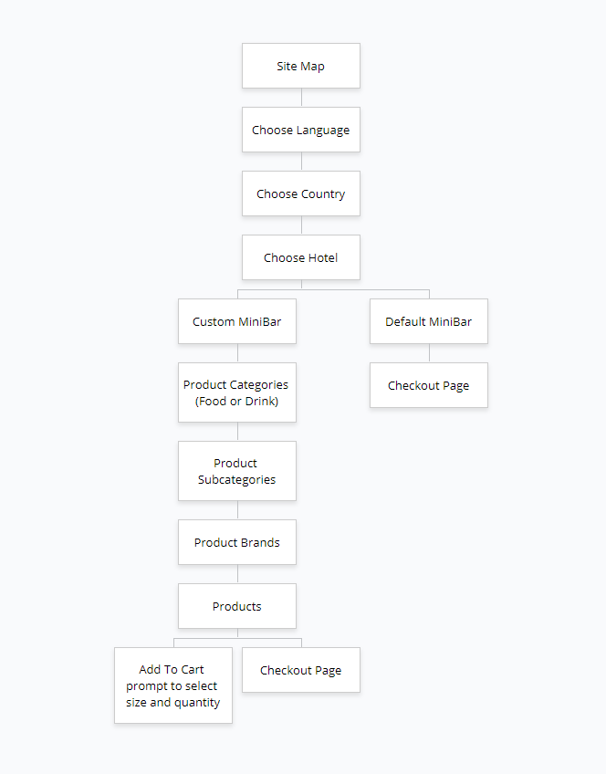

***Admin Panel:***

Through the admin panel the admin will be able to add, edit and delete products.

When adding or editing a product there will be the following properties.

Name and description in several languages, Category, Subcategory, Brand, What sizes can a product be.

Also, the admin can translate messages into the supported languages.

***Duration:***

Two months after confirming the design.